|  |  |  |  |  |  |  |
| --- | --- | --- | --- | --- | --- | --- |
|  | |  |  | | --- | --- | |  | **FPT ACADEMY INTERNATIONAL**  **FPT – APTECH COMPUTER EDUCATION** | |  |  | |  |

Center Name: ACE-HCMC-2-FPT.

Address: 590 Cach Mang Thang 8 Street, District 3, Ho Chi Minh City, Vietnam.



**Bakery Store**

**Design Document**

|  |  |  |  |
| --- | --- | --- | --- |
| **Faculty:** |  | **Ms. Le Mong Thuy** |  |
| **Batch No:** |  | **T1.2109.M1** |  |
| **Group No:** |  | **5** |  |
| **Students:** |  | **Fullname** | **Roll No.** |
|  | 1. | Lê Minh Trung | Student1339040 |
|  | 2. | Nguyễn Gia Thiện | Student1335976 |
|  | 3. | Đổng Thái Tuấn | Student1322489 |
|  | 4. | Phạm Nhật Minh | Student1328429 |

**June, 2022**

Mục Lục

**Table of Contents**

**June, 2022** 0

REVIEW 1 3

REVIEW 2 9

REVIEW 3 51

# REVIEW 1

**INTRODUCTION**

Nowadays, information technology plays an important role in our life it develops day by day and non-stop. Advanced technology makes buying and selling easier than ever, we have running surveys about ordering food online or going to traditional bakery, and we kinder surprise that many people prefer to order food online than go to traditional bakery. Therefore, we developed a website named ‘Bakery Store’ for people who want to buy pastry, cake online.

The main reason that we developed ‘Bakery store’ is selling pastry, cake online in the inner city, HCM city is the one that we are shipping in this case. It will provide the users following features:

* Unregistered users can register member accounts.
* Registered users can login and manage their profile.
* Unregister, member can search for the products in the store by products name.
* Unregistered, member can sort by price ASC, DESC.
* Unregistered, member can preview the products before adding to the cart.
* Users can see their favorite products.
* Unregistered, member can add the products to cart.

(All the features below here all user have to login to use)

* Users can check out the products after adding them to the cart.
* Users can Payment.
* Users can see the details of the order.
* Users can see the order status.
* Users can interact with the website to cancel the orders.
* Users can leave feedback and comment on the product.

**PROBLEM DEFINITION**

After analyzing the project specifications of ‘Bakery Store’, we came to the conclusion and following queries:

**FROM THE VIEW POINT OF USERS**

* A homepage will show few information, introduction, suitable logo and search bar.
* A navigation header and footer will display the functions implemented in the website.
* Users (Unregistered) can sign up, search (by name), see details of products, adding products to cart, and view cart, and see their favorite products.
* Users(Registered) can search(by name), filter (by price), view details of products, buy products, add products to the cart, delete the products out of cart, view cart, checkout, payment, view order history, details of orders, order status and finally they can manage their profile.

**FROM THE VIEW POINT OF ADMINISTRATOR**

* A login page will grant access to ‘Bakery Store’ admin.
* Admin can manage the products, users, blog, order status.

**CUSTOMER’S REQUIREMENTS SPECIFICATIONS**

**CLIENT: Bakery Store**

**BUSINESS/PROJECT OBJECTIVE:**

The project is to design an online website for advertising and selling pastry, cake. For instance, whole cake, slices cake, seasonal, etc.

**INPUT TO THE SYSTEM:**

**‘Bakery Store’ administrators need to provide:**

* Information required to login into admin account.

**Users ‘Bakery Store’ need to provide:**

* Personal information to register a member account.
* Personal information to buy check out, payment.

**OUTPUT FROM THE SYSTEM:**

**‘Bakery Store’ administrator will be able to:**

* Login/Logout to the admin system.
* Manage (view, update, delete, insert) the products, blog.
* Manage (view, update) the user's account.
* Manage (view, update, delete) the orders, orders status.

**‘Bakery Store’ users (not have a member account) will be able to:**

* Registered member account.
* Buy products after login and input personal information.
* Search products by name.
* Filter by price ASC, DESC.
* View cart, favorite product.

**‘Bakery Store’ users (have member account) will be able to:**

* Login/logout member account.
* Manage their profile.
* View their favorite products.
* View orders details and status of orders, order history.

**Scope of work:**

  The application should perform all the following features.

**Login**

* We divide into two type of account
* First, Administrator, the Administrator can manage product, blog, users, order status, Administrators can view and update the user’s information.
* Second, Member, the member can search, filter price, view product details, add products into the cart and delete products out of cart, check out, payment.

Members can view the order details, status and buy the products, view favorite products.

**SEARCH, filter by price (ASC, DESC), favorite product**

* Input product name in to search bar and ‘ENTER’ the web will display the following name product.
* You can order by price by choose “Low to high”, “High to low”.
* After hit heart button of products, you can see your favorite product by click HEART BUTTON in Navigation bar.

**Check out, Payment**

* When users ‘add to cart’ the product, the products will be added to the cart, and the Check Out at here customer will fill information and then Payment to complete the order.

**DATABASE**

The information about user, product, orders, orders details, order status, etc will be store in database

**TECHNOLOGY**

* PHP-Laravel Framework
* Javascript
* Jquery
* HTML-CSS-Bootstrap
* Ajax

TASK SHEET REVIEW 1

|  |  |  |  |  |  |  |  |  |
| --- | --- | --- | --- | --- | --- | --- | --- | --- |
| Project: Bakery Store | | Project name | Activity  Plan  Prepared  By | | Date Of Preparation Of Activity Plan: | | | |
| No | Introduction | Actual Start Date | Actual  Day | Team  Member  Name | Status |
| 1 | Introduction | Bakery Store | Thiện | | 29-June-2022 | 1 | Thiện | Completed |
| 2 | Problem Definition | 29-June-2022 | 1 | Thiện | Completed |
| 3 | Customer’s requirements specifications | 29-June-2022 | 1 | Thiện | Completed |
| 4 | Scope of work | 29-June-2022 | 1 | Thiện | Completed |
| 5 | Task Sheet | 29-june-2022 | 1 | Thiện | Completed |
| Date: 29-June-2022 | | | | | | | | |
| Signature of instructor  Ms. Lê Mộng Thúy | | | | Signature of team leader  Mr. Lê Minh Trung | | | | |

|  |  |  |
| --- | --- | --- |
|  | Prepare By: Group 5 | Approved By: Faculty |
| Date: | Team Leader  **Le Minh Trung** | **Ms. Le Mong Thuy** |

# REVIEW 2

**1. USECASE**

**VISITOR**

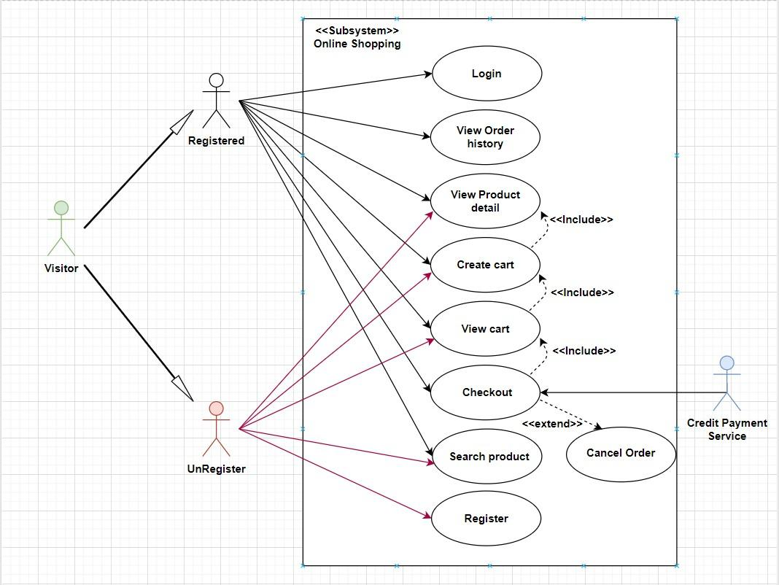

**LOGIN AS CUSTOMER:**

|  |  |  |  |
| --- | --- | --- | --- |
| **Author** |  | | |
| **Use Case Name** | Login | | |
| **Actors** | Customer | | |
| **Description** | Customer who has registered an account can login | | |
| **Requirements** | Customer provides username and password | | |
| **Pre-conditions** | Visitor must register an account | | |
| **Post-conditions** | Success: Visitor is logged in to website | | |
| Fail: Refill information | | |
| **Basic flow** | **Actor’s actions:** | **System’s responses:** | |
| 1. Visitor clicks ‘Login’ button on Home Page.  3. Actor inputs Email and Password, then click the ‘Login’ button. | 2. System redirects to Login Page with the following controls:  - “Email” text field  - “Password” text field  - “Login” button  4. System checks the information  5. System redirects to Customer’s dashboard. | |
| **Exceptions** | **Actor’s actions:** | **System’s responses:** | |
| 1.Actor password. Inputs invalid email | and | System redirects to Login page with the following controls:  - “Email” text field  - “Password” text field  - “Login” button  System shows message: “Invalid email and password”. |

**REGISTER AS VISITOR:**

|  |  |  |
| --- | --- | --- |
| **Author** |  | |
| **Use Case Name** | Register as Visitor | |
| **Actors** | Customer | |
| **Description** | Customer who has registered an account can login | |
| **Requirements** | Customer registers an account on the website and becomes a member | |
| **Pre-conditions** | Customer provides their register information | |
| **Post-conditions** | Success: Visitor creates a User account in this website | |
| Fail: Refill information | |
| **Basic flow** | **Actor’s actions:** | **System’s responses:** |
| 1. Visitor clicks “Register” button on Home Page  3. Visitor inputs register’s information and click “Register” button.. | 2. System redirects to Register page and displays Registration form with the following controls:  “Username” text field  “Password” text field  “Confirm Password” text field  “Email” text field  “Phone” text field  “Register” button  “Reset” button  4. System validates the information.  5. System inserts the account into database  6. System show success message. |

|  |  |  |
| --- | --- | --- |
| **Exceptions** | **Actor’s actions:** | **System’s responses:** |
| Actor left “Username” text field blank.  Username has already existed.  Actor left “Password” text field blank.  Actor left “Confirm Password” text field blank.  -Password and confirm password don’t match.  Actor left “Email” text field blank.  Email has already existed.  Actor left “Phone” text field blank.  Input phone is not numeric format or phone length is not between 8 and 14 characters.  Actor left “Email” text field blank or input an invalid email address. | System displays message to customer:  “Username cannot be blank”.  “This Username has already existed”.  “Password cannot be blank”.  “Confirm Password cannot be blank”.  “Confirm Password does not match password.”.  “Email cannot be blank”.  “This Email has already existed”.  “Phone cannot be blank”.  “The phone number should be numeric only and must be between 8 and 14 digits”.  “Email is invalid”. |

**SEARCH PRODUCTS:**

|  |  |  |
| --- | --- | --- |
| **Author** |  | |
| **Use case name** | Search product | |
| **Actors** | Registered Customer/ New Customer | |
| **Description** | Customer can search product | |
| **Requirements** | Customer provides search phrase | |
| **Pre-conditions** | N/A | |
| **Post-conditions** | Success: Show product that matches search phrase | |
| Fail: No product is shown | |
| **Basic flow** | **Actor’s actions:** | **System’s responses:** |
| 1. Actor inputs search phrase.  3. Actor clicks product’s name in list or view every product that matches search phrase. | 2. System shows list of products that match the search phrase. |

**VIEW FAVORITE PRODUCT:**

|  |  |  |
| --- | --- | --- |
| **Author** |  | |
| **Use case name** | Favorite Product | |
| **Actors** | Registered Customer/ New Customer | |
| **Description** | Customer can add, view favorite product | |
| **Requirements** | Customer hit favorite button | |
| **Pre-conditions** | Reload page | |
| **Post-conditions** | Success: Show favorite product in favorite product page | |
| Fail: No product is shown | |
| **Basic flow** | **Actor’s actions:** | **System’s responses:** |
| 1. Actor add favorite.  3. Actor view favorite product in favorite product page. | 2. System add into the local storage. |

**VIEW PRODUCT DETAIL:**

|  |  |  |
| --- | --- | --- |
| **Author** |  | |
| **Use case name** | View product | |
| **Actors** | Registered Customer/ New Customer | |
| **Description** | Customer can view product detail | |
| **Requirements** | Customer select product to show product’s detail | |
| **Pre-conditions** | N/A | |
| **Post-conditions** | Success: Display product detail matching the selected product | |
| Fail: No product is shown | |
| **Basic flow** | **Actor’s actions:** | **System’s responses:** |
| 1. Actor select product | 2. System shows product’s detail matching selected product |

**CREATE CART:**

|  |  |  |
| --- | --- | --- |
| **Author** |  | |
| **Use case name** | Create cart | |
| **Actors** | Registered customer | |
| **Description** | Customer can add product to their cart | |
| **Requirements** | Customer must choose at least one product | |
| **Pre-conditions** | Customer must log in before adding product | |
| **Post-conditions** | Success: Actor add product to cart successfully | |
| Fail: Refill information | |
| **Basic flow** | **Actor’s actions:** | **System’s responses:** |
| 1. Actor chooses a product and click “Add to cart”. | 2. System adds selected product to cart by id of this product. |
| **Exceptions** | **Actor’s action** | **System’s response** |
| 1. Actor inputs more products than there are in stock. | 2. System shows messages:  - “Product out of stock”. |

**VIEW CART:**

|  |  |  |
| --- | --- | --- |
| **Author** |  | |
| **Use case name** | View cart | |
| **Actors** | Registered customer | |
| **Description** | Customer can view their cart | |
| **Requirements** | N/A | |
| **Pre-conditions** | Customer must log in before view cart | |
| **Post-conditions** | Success: Customer can view their cart | |
| Fail: Refill information | |
| **Basic flow** | **Actor’s actions:** | **System’s responses:** |
| 1. Actor click on “Cart” icon. | 2. System shows cart and added products. |
| **Alternative flow** | 1. Actor clicks “x”– Close button- on table  3. Actor change quantity of a product  5. Actor clicks “x”  – close button  – in the right side of each product. | 2. System redirects to current page.  4. System update quantity of this product into cart.  6. System removes this product from cart. |

**CHECKOUT:**

|  |  |  |
| --- | --- | --- |
| **Author** |  | |
| **Use case name** | Check out and Place order | |
| **Actors** | Registered customer | |
| **Description** | Customer can order products | |
| **Requirements** | Customer must has at least 1 product in cart | |
| **Pre-conditions** | Customer must log in before adding product | |
| **Post-conditions** | Success: Actor order successfully | |
| Fail: Refill information | |
| **Basic flow** | **Actor’s actions:** | **System’s responses:** |
| 1. Actor click “Add to cart” button or “Cart” icon.  3. Actor clicks “Check out with” button.  5. Actor inputs order information then click “Place Order” button.  6. Actor inputs Card owner’s name, card number and security code if actor choose payment by credit card.  9. Actor views order’s status in Order page. | 2. System shows cart and added products.  4. System shows all products in cart with calculated total price and show following controls:  - “Customer name” text field.  - “Phone” text field.  - “Address” text field.  - “Province” select box.  - “Delivery time frame” select box.  - “Payment” table.  6. Systems shows Payment tab type according to type of payment actors choose.  7. System validates information.  8. System redirects to Order page and show order’s status. |

|  |  |  |
| --- | --- | --- |
| **Alternative flow** | 1. Actor clicks “X”– Close button- on table  3. Actor clicks “X” button on each product.  5. Actors clicks “Home” button. | 2. System redirects to cart page.  4. System removes product from cart.  6. System redirect to Home pages. |
| **Exceptions** | **Actor’s action** | **System’s response** |
| 1. Actor inputs more products than there are in stock.  2. Actor left “Billing name” text field blank.  3. Actor left “Address” text field blank.  4. Actor left “Delivery date” blank.  5. Actor left “Delivery time frame” blank.  6. Actor left “Payment” dropdown blank.  7. Actor inputs invalid card information. | 8. System shows messages:  - “Product out of stock”.  - “Order name must not be blank”.  -“Address must not be blank”.  -“Must choose a delivery date”.  -“Must choose a delivery time frame”.  -“Must choose a payment method”.  -“Invalid card”. |

**VIEW ORDER HISTORY:**

|  |  |  |
| --- | --- | --- |
| **Author** |  | |
| **Use case name** | View order history | |
| **Actors** | Registered customer | |
| **Description** | Customer can view their order history | |
| **Requirements** | N/A | |
| **Pre-conditions** | Customer must log in to website | |
| **Post-conditions** | Success: Customer can view their order. | |
| Fail: Customer cannot see their order. | |
| **Basic flow** | **Actor’s actions:** | **System’s responses:** |
| 1. Actor chooses “Account” icon on Menu  3. Actor chooses “Purchase history” on  sides bar.  5. Actor selects the order that they want to view in “Purchase history” and clicks “View” Button. | 2. System redirects to Account page.  4. System redirects to “Purchase history” page and displays a list of existing orders and their status.  6. System validates inputs by id of Order.  7. System displays all order’s detail and its status. |

**CANCEL ORDER:**

|  |  |  |
| --- | --- | --- |
| **Author** |  | |
| **Use case name** | Cancel order | |
| **Actors** | Registered customer | |
| **Description** | Customer can cancel their order | |
| **Requirements** | Customer provides order’s id to cancel | |
| **Pre-conditions** | Customer must log in to website and only can cancel when this order has not been confirmed by admin | |
| **Post-conditions** | Success: Cancel successfully. | |
| Fail: Order cannot cancel. | |
| **Basic flow** | **Actor’s actions:** | **System’s responses:** |
|  | 1. Actor chooses “Account” icon on Menu  3. Actor chooses “Purchase history” on sides bar.  5. Actor selects the order that they want to cancel in “Purchase history” and clicks “Cancel” button. | 2. System redirects to Account page.  4. System redirects to “Purchase history” page and displays a list of existing orders.  6. System validates inputs by id of order.  7. System change order status in database.  8. System displays message: successful for error. |
|  |
|  |
|  |
|  |

**ADMIN**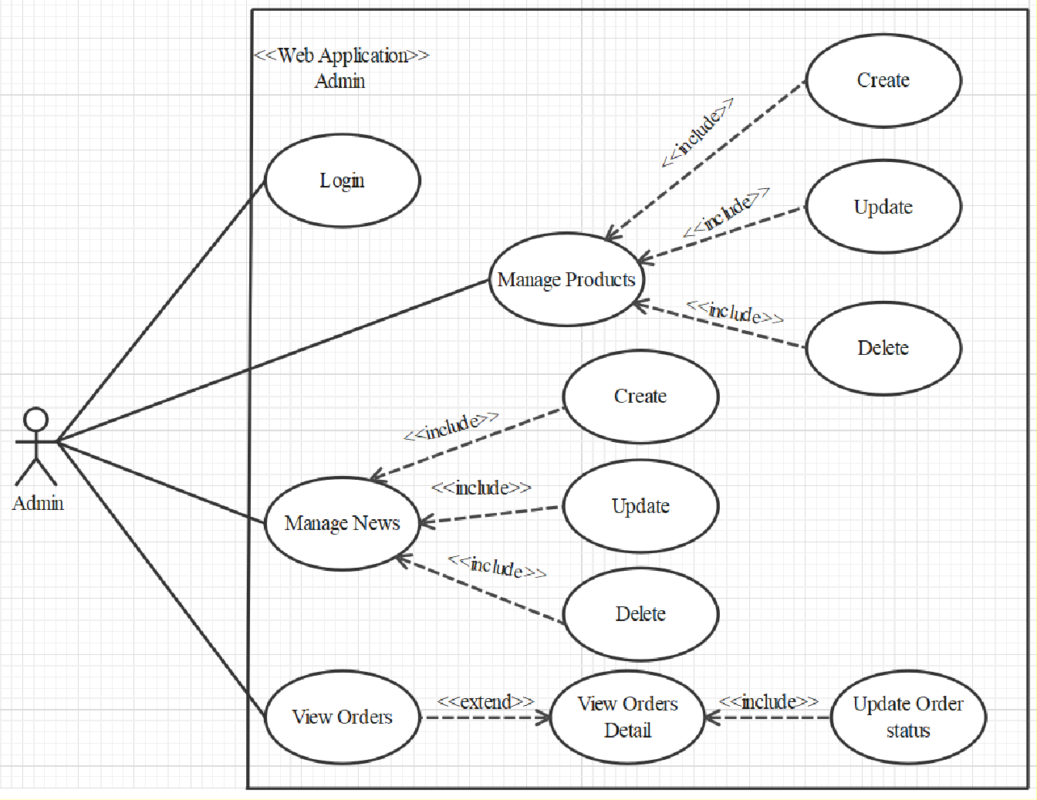

**LOGIN**

|  |  |  |
| --- | --- | --- |
| **Author** |  | |
| **Use case name** | Login | |
| **Actor** | Admin | |
| **Description** | When admin wants to manage products, news, views orders and orders detail | |
| **Requirements** | Admin provides username and password | |
| **Pre-conditions** | Admin must be exist on database | |
| **Post-conditions** | Success: Admin is logged in to website admin | |
| Fail: refill information | |
| **Basic flow** | **Actor’s actions:** | **System’s responses:** |
| 1. Actor clicks on ‘Login’ button.  3. Actor inputs Email and Password, then click the ‘Login’ button. | 2. System redirects to Login Page with the following controls:  'Email' text field  'Password' text field  'Login' button  System validates the information.  System redirects to Admin website |
| **Exceptions** | **Actor’s actions:** | **System’s responses:** |
| 1. Actor inputs invalid email and password | System redirects to Login page with the following controls:  ‘Email’ text field  ‘Password’ text field  ‘Login’ button. |

**PRODUCTS**

**Create new Product**

|  |  |  |
| --- | --- | --- |
| **Author** |  | |
| **Use case name** | Create new product | |
| **Actor** | Admin | |
| **Description** | When admin wants to create a new product | |
| **Requirements** | Actor provides product’s information | |
| **Pre-conditions** | Actor is logged in admin | |
| **Post-conditions** | Success: new product is added into the database | |
| Fail: refill information | |
| **Basic flow** | **Actor’s actions:** | **System’s responses:** |
| 1. Actor chooses Product Tab on menu.  3. Actor clicks ‘Add New Product’ button.  5. Actor inputs information to create new product | 2. System redirects to ‘Product’ page and display a list of existing product.  4. System displays a form with the following fields:  - product_id, product_name, product_image, product_price, product_description, category_id, product_star.  6. System validates inputs.  7. System adds product into database.  8. System displays confirmation message or error message. |

**Search Product**

|  |  |  |
| --- | --- | --- |
| **Author** |  | |
| **Use Case Name** | Search Product | |
| **Actors** | Admin | |
| **Description** | When admin wants to find product by name | |
| **Requirements** | Actor provides product name | |
| **Pre-conditions** | Actor is logged in admin | |
| **Post-condition** | Success: Show product that matches name | |
| Fail: No product is shown | |
| **Basic flow** | **Actor’s action** | **System’s responses:** |
| 1 Actor inputs name.  3. Actor clicks customer’s title in list or view, which matches the name. | 2. System show list of customer that match the name. |

**Update Product**

|  |  |  |
| --- | --- | --- |
| **Author** |  | |
| **Use case name** | Update product’s detail | |
| **Actor** | Admin | |
| **Description** | When admin wants to update product | |
| **Requirements** | Actor provides product’s information | |
| **Pre-conditions** | Actor is logged in admin | |
| **Post-conditions** | Success: product is updated in the database | |
| Fail: refill information | |
| **Basic flow** | **Actor’s actions:** | **System’s responses:** |
| 1. Actor chooses Product Tab on menu.  3. Actor clicks on ‘Edit on a product.  5. Actor chooses the criteria they want to update and input information. | 2. System redirects to ‘Product’ page and display a list of existing product.  4. System displays a form with the following fields:  - id , category_id , sale_id , name , name_slug , description , price , view_count , quantity , active , detail , image  6. System validates inputs.  7. System update product into database.  8. System displays confirmation message or error message.  9. System redirects to product’s detail page. |

**Delete Product**

|  |  |  |
| --- | --- | --- |
| **Author** |  | |
| **Use case name** | Delete Product | |
| **Actor** | Admin | |
| **Description** | When admin wants to delete product from the database | |
| **Requirements** | Admin provides product’s information | |
| **Pre-conditions** | Actor is logged in admin | |
| **Post-conditions** | Success: product is delete in the database | |
| Fail: product is not delete from the database | |
| **Basic flow** | **Actor’s actions:** | **System’s responses:** |
| 1. Actor chooses Product Tab on menu.  3. Actor clicks ‘Delete’ button. | 2. System redirects to ‘Product List’ page and display a list of existing product.  4. System delete product in the database  5. System displays confirmation or error. |

**MANAGE**

**CREATE NEW MANAGE**

|  |  |  |
| --- | --- | --- |
| **Author** |  | |
| **Use case name** | Create News | |
| **Actor** | Admin | |
| **Description** | When admin wants to create a News | |
| **Requirements** | Admin provides New content | |
| **Pre-conditions** | Actor is logged in admin | |
| **Post-conditions** | Success: News content is added into the website | |
| Fail: admin can’t create News | |
| **Basic flow** | **Actor’s actions:** | **System’s responses:** |
| 1. Actor chooses News Tab on menu.  3. Actor clicks ‘Add New Content’ button.  5. Actor inputs information to create news | 2. System redirects to ‘News’ page and display a list of News.  4. System displays a form with the following fields:  id , name , content , image  6. System validates inputs.  7. System adds News into website.  8. System displays confirmation message or error message. |

**UPDATE MANAGE**

|  |  |  |
| --- | --- | --- |
| **Author** |  | |
| **Use case name** | Update News on the website | |
| **Actor** | Admin | |
| **Description** | When admin wants to update news information | |
| **Requirements** | Admin provides News Content | |
| **Pre-conditions** | Actor is logged in admin | |
| **Post-conditions** | Success: News is updated in the website | |
| Fail: admin can’t update News | |
| **Basic flow** | **Actor’s actions:** | **System’s responses:** |
| 1. Actor chooses News Tab on menu.  3. Actor clicks ‘View Details’ button.  5. Actor chooses the criteria they want to update and input information. | 2. System redirects to ‘News’ page and display a list of News.  4. System displays a form with the following fields.  - name  - content  - image  6. System validates inputs.  7. System update News Content to website.  8. System displays confirmation message or error message.  9. System redirects to Home. |

**DELETE MANAGE**

|  |  |  |
| --- | --- | --- |
| **Author** |  | |
| **Use case name** | Delete News | |
| **Actor** | Admin | |
| **Description** | When admin wants to delete News from the website | |
| **Requirements** | Admin provides News Content | |
| **Pre-conditions** | Actor is logged in admin | |
| **Post-conditions** | Success: product is delete in the website | |
| Fail: product is not delete from the website | |
| **Basic flow** | **Actor’s actions:** | **System’s responses:** |
| 1. Actor chooses News Tab on menu.  3. Actor clicks ‘Delete’ button. | 2. System redirects to ‘News List’ page and display a list of News.  4. System delete News in the website  5. System displays confirmation or error. |

**VIEW ORDER**

|  |  |  |
| --- | --- | --- |
| **Author** |  | |
| **Use case name** | View Order | |
| **Actor** | Admin | |
| **Description** | When admin wants to know the order of the product | |
| **Requirements** | Admin has at least 1 order on website. | |
| **Pre-conditions** | Actor is logged in admin | |
| **Post-conditions** | Success: product is shown in the website | |
| Fail: Page View Order cannot see from the website | |
| **Basic flow** | **Actor’s actions:** | **System’s responses:** |
| 1. Actor chooses View Order on menu.  3. Actor clicks ‘View’ button. | 2. System redirects to ‘Order List’ page and display a list of Order.  4. System show Order in the website.  5. System displays confirmation or error. |

**VIEW ORDER DETAIL**

|  |  |  |
| --- | --- | --- |
| **Author** |  | |
| **Use case name** | View Order Detail | |
| **Actor** | Admin | |
| **Description** | When admin wants to see View Order Detail from the website | |
| **Requirements** | Admin has at least 1 order on website. | |
| **Pre-conditions** | Actor is logged in admin | |
| **Post-conditions** | Success: Admin can view Order Detail on the website | |
| Fail: Admin cant’ view the Order Detail on the website | |
|  | **Actor’s actions:** | **System’s responses:** |
| **Basic flow** | 1. Actor chooses View Order on menu.  3. Actor clicks ‘Detail’ button. | 2. System redirects to ‘Order List’ page and display a list of Order.  4 System show Order Details in the website  5. System displays confirmation or error. |

**UPDATE ORDER STATUS**

|  |  |  |
| --- | --- | --- |
| **Author** |  | |
| **Use case name** | Update Order Status | |
| **Actor** | Admin | |
| **Description** | When admin wants to update Order Status from the website | |
| **Requirements** | Admin has at least 1 order on website. | |
| **Pre-conditions** | Actor is logged in admin | |
| **Post-conditions** | Success: Admin can update Order Status on the website | |
| Fail: Admin can’t update Order Status on the website | |
| **Basic flow** | **Actor’s actions:** | **System’s responses:** |
| 1. Actor chooses View Order Tab on menu.  3. Actor clicks ‘Delete’ button. | 2. System redirects to ‘Order List’ page and display a list of Order.  4. System update Order Status in the website  5. System displays confirmation or error. |

**WEBSITE ADMINISTRATOR**

**UPDATE CUSTOMER**

|  |  |  |  |
| --- | --- | --- | --- |
| **Author** |  | |  |
| **Use Case Name** | Update Customer | |
| **Actors** | Admin | |
| **Description** | When admin wants to Update customer | |
| **Requirements** | Actor provides customer information | |
| **Pre-conditions** | Actor is logged in admin | |
| **Post-condition** | Success: Customer is update into the database | |
| Fail: refill information | |
| **Basic flow** | **Actor’s action** | **System’s responses:** |
| 1. Actor chooses Customer Tab on menu.  3. Actor clicks on ‘View Details’ on a Customer  5. Actor chooses the criteria they want to update and input information. | 2. System redirects to ‘Customer’ page and display a list of existing Customers.  4. System displays a form with the following fields:  Fullname , username , password , address , phone , email , birthday , gender , active  6. System validates inputs.  7. System update customer into database.  8. System displays confirmation message or error message.  9. System redirects to customer’s detail page. |

**DELETE CUSTOMER**

|  |  |  |
| --- | --- | --- |
| **Author** |  | |
| **Use Case Name** | Delete Customer | |
| **Actors** | Admin | |
| **Description** | When admin wants to delete customer | |
| **Requirements** | Actor provides customer information | |
| **Pre-conditions** | Actor is logged in admin | |
| **Post-condition** | Success: Customer is delete from the database | |
| Fail: Customer is not deleted from the database | |
| **Basic flow** | **Actor’s action** | **System’s responses:** |
| 1. Actor chooses Customer Tab on menu.  3. Actor clicks ‘Delete’ button. | 2. System redirects to ‘Customer’ page and display a list of existing Customers.  4. System delete customer in the database.  5. System displays confirmation message or error message. |

**FIND CUSTOMER**

|  |  |  |
| --- | --- | --- |
| **Author** |  | |
| **Use Case Name** | Find Customer | |
| **Actors** | Admin | |
| **Description** | When admin wants to find customer by ID | |
| **Requirements** | Actor provides Customer’s id | |
| **Pre-conditions** | Actor is logged in admin | |
| **Post-condition** | Success: Show customer that matches ID | |
| Fail: No customer is shown | |
| **Basic flow** | **Actor’s action** | **System’s responses:** |
| 1 Actor inputs ID.  3. Actor clicks customer’s title in list or view, which matches the ID. | 2. System show list of customer that match the ID. |

**2. DATA FLOW DIAGRAM (DFD)**

**LEVEL 0**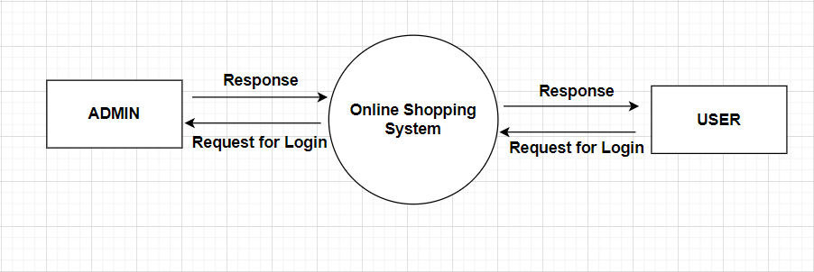

**ADMINSIDE LEVEL 1**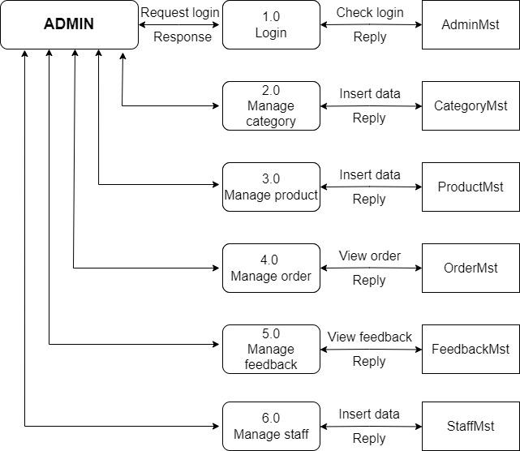

**ADMIN SIDE LEVEL 2**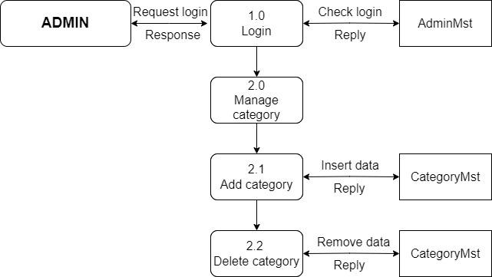

**ADMINSIDE LEVEL 3**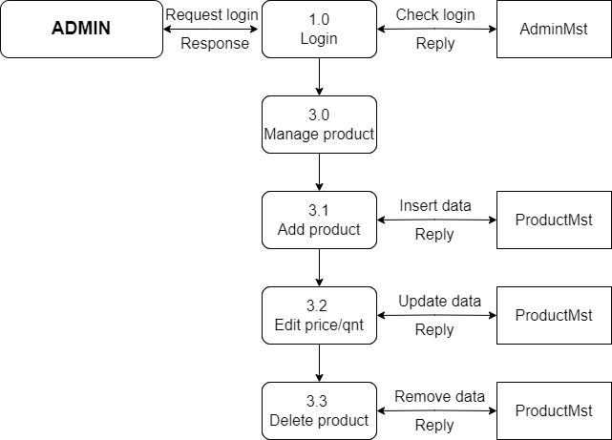

**ADMINSIDE LEVEL 4**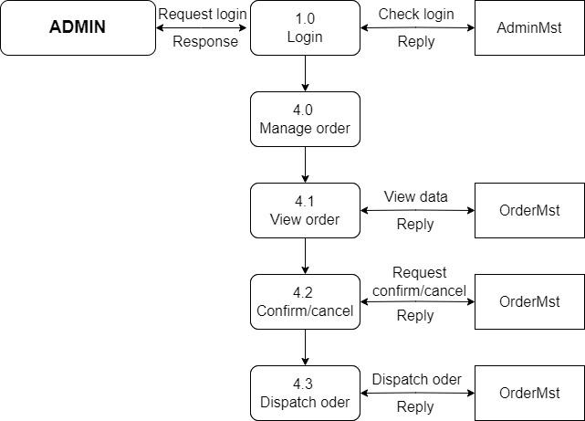

**ADMINSIDE LEVEL 5**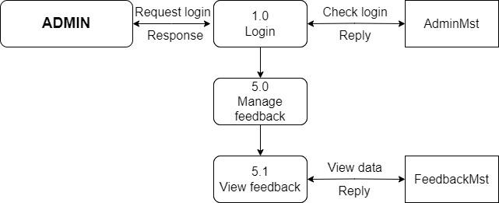

**ADMINSIDE LEVEL 6**

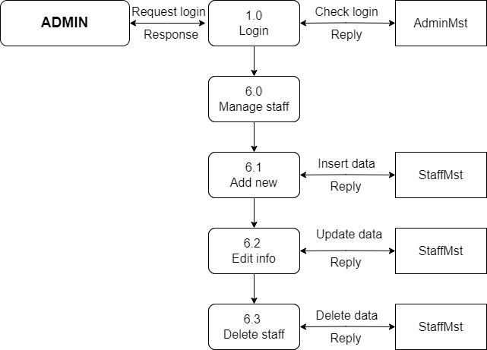

**USERSIDE LEVEL 1**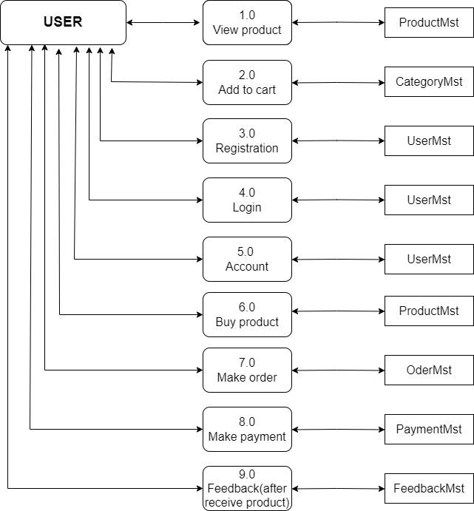

**USERSIDE LEVEL 2**

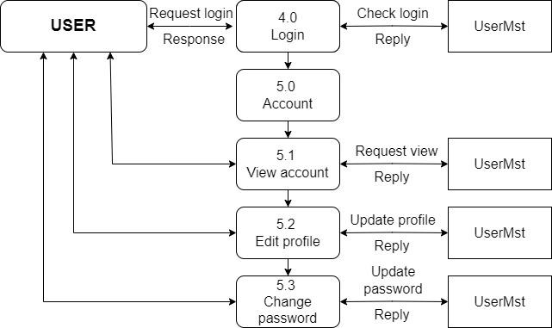

**4. ENTITY RELATIONSHIP DIAGRAM (ERD)**

**LOGICAL ERD**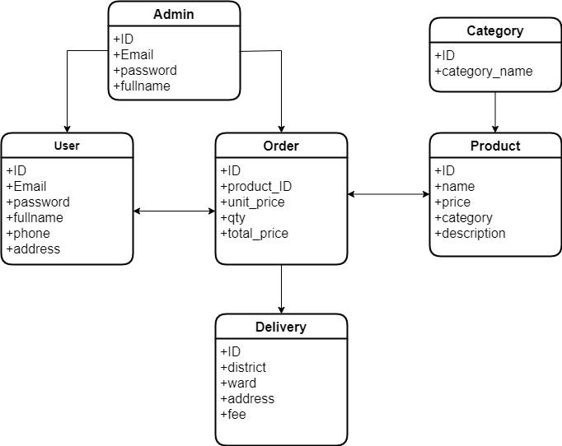

**5. TABLE DESIGN**

**TABLE STRUCTURE FOR TABLE USERS**

|  |  |  |  |
| --- | --- | --- | --- |
| **TABLE USERS** | | | |
| **Column** | **Type** | **Null** | **Default** |
| **id** | Bigint | No |  |
| **name** | Varchar | No |  |
| **email** | Varchar | No |  |
| **password** | Varchar | No |  |
| **profile_pic** | Varchar | No | null |
| **phone** | Int | No |  |
| **address** | Varchar | No |  |
| **is_staff** | Tinyint | No | 0 |
| **is_active** | Tinyint | No | 1 |

**TABLE STRUCTURE FOR TABLE PRODUCT**

|  |  |  |  |
| --- | --- | --- | --- |
| **TABLE PRODUCT** | | | |
| **Column** | **Type** | **Null** | **Default** |
| **Product_id** | Int | No |  |
| **Product_name** | Varchar | No |  |
| **Product_price** | Int | No |  |
| **Product_images** | Varchar | No | NULL |
| **category_id** | Int | No |  |
| **Product_description** | text | No |  |
| **Category_id** | varchar | No |  |
| **Product_star** | float | Yes |  |
|  |  |  |  |

**TABLE STRUCTURE FOR TABLE ORDER**

|  |  |  |  |
| --- | --- | --- | --- |
| **TABLE ORDER** | | | |
| **Column** | **Type** | **Null** | **Default** |
| **id** | int | No |  |
| **created_date** | datetime | No | **current_timestamp()** |
| **order_status_id** | int | No | **1** |
| **customer_id** | bigint | Yes | **NULL** |
| **shipping_fullname** | varchar | No |  |
| **email** | varchar | Yes | **NULL** |
| **phone** | int | No |  |
| **payment_method** | tinyint | No | **0** |
| **coupon_id** | int | Yes | **NULL** |
| **address** | varchar | No |  |
| **delivered_at** | date | Yes | **NULL** |

**TABLE STRUCTURE FOR TABLE ORDER_ITEM**

|  |  |  |  |
| --- | --- | --- | --- |
| **TABLE ORDER_ITEM** | | | |
| **Column** | **Type** | **Null** | **Default** |
| **product_id** | Int | No |  |
| **order_id** | Int | No |  |
| **qty** | Int | No |  |
| **unit_price** | Int | No |  |
| **total_price** | Int | No |  |

**TABLE STRUCTURE FOR TABLE STATUS**

|  |  |  |  |
| --- | --- | --- | --- |
| **TABLE STATUS** | | | |
| **Column** | **Type** | **Null** | **Default** |
| **id** | Int | No |  |
| **name** | Varchar | No |  |
| **description** | Varchar | No |  |

**TABLE STRUCTURE FOR TABLE COMMENT**

|  |  |  |  |
| --- | --- | --- | --- |
| **TABLE COMMENT** | | | |
| **Column** | **Type** | **Null** | **Default** |
| **id** | int | No |  |
| **product_id** | Int | No |  |
| **email** | Varchar | No |  |
| **fullname** | Varchar | No |  |
| **star** | float | No |  |
| **created_date** | datetime | No |  |
| **description** | text | No |  |

**TABLE STRUCTURE FOR TABLE FAILED_JOBS**

|  |  |  |  |
| --- | --- | --- | --- |
| **TABLE FAILE_JOBS** | | | |
| **Column** | **Type** | **Null** | **Default** |
| **id** | bigint | No |  |
| **uuid** | Varchar | No |  |
| **connection** | text | No |  |
| **queue** | text | No |  |
| **payload** | longtext | No |  |
| **exception** | longtext | No |  |
| **failed_at** | timestamp | No | **current_timestamp()** |

**TASK SHEET REVIEW 2**

|  |  |  |  |  |  |  |  |
| --- | --- | --- | --- | --- | --- | --- | --- |
| **Project: Liquor Stores** | | **Project Name** | **Activity Plan Prepared By** | **Date of Preparation of Activity Plan:** | | | |
| **No.** | **Task** | Actual Start Date | Actual Days | Member name | Status |
| **1** | **Use Case** | **BakeryStore** | Trung | 25-Jun-22 | 3 | Minh | Completed |
| **2** | **Data Flow Diagram (DFD)** | 25-Jun-22 | 3 | Minh | Completed |
| **3** | **Entity Relationship Diagram (ERD)** | 25-Jun-22 | 3 | Minh | Completed |
| **4** | **Entity Properties** | 25-Jun-22 | 3 | Minh | Completed |
| **5** | **Table Design** | 25-Jun-22 | 3 | Minh | Completed |
| Date: 29 April 2022 | | | | | | | |
| **Signature of Instructor:**  Ms. Le Mong Thuy | **Signature of Team Leader:**  Le Minh Trung |

# REVIEW 3

* + - 1. SITE MAP

User site map 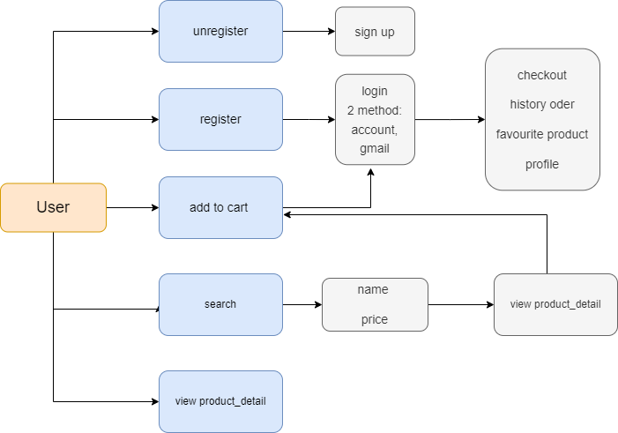

ADMIN SITE MAP

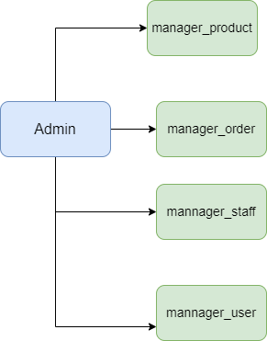

2.BakeryStore SCREENSHOT

CUSTOMER PAGE

HOME PAGE

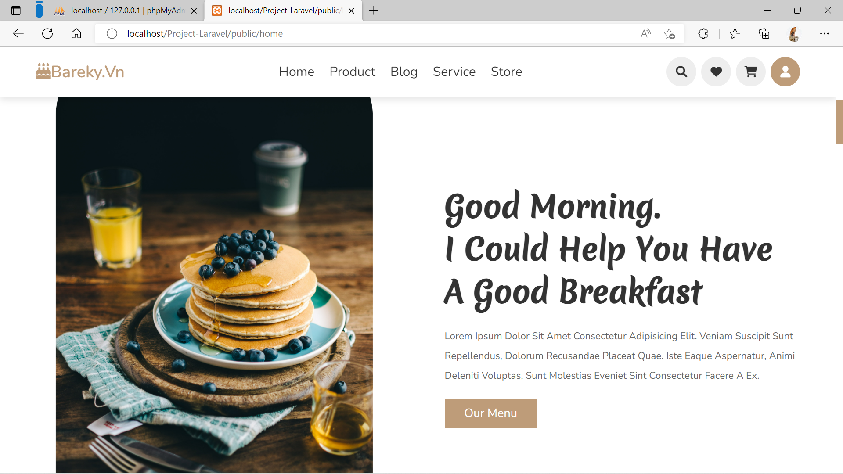

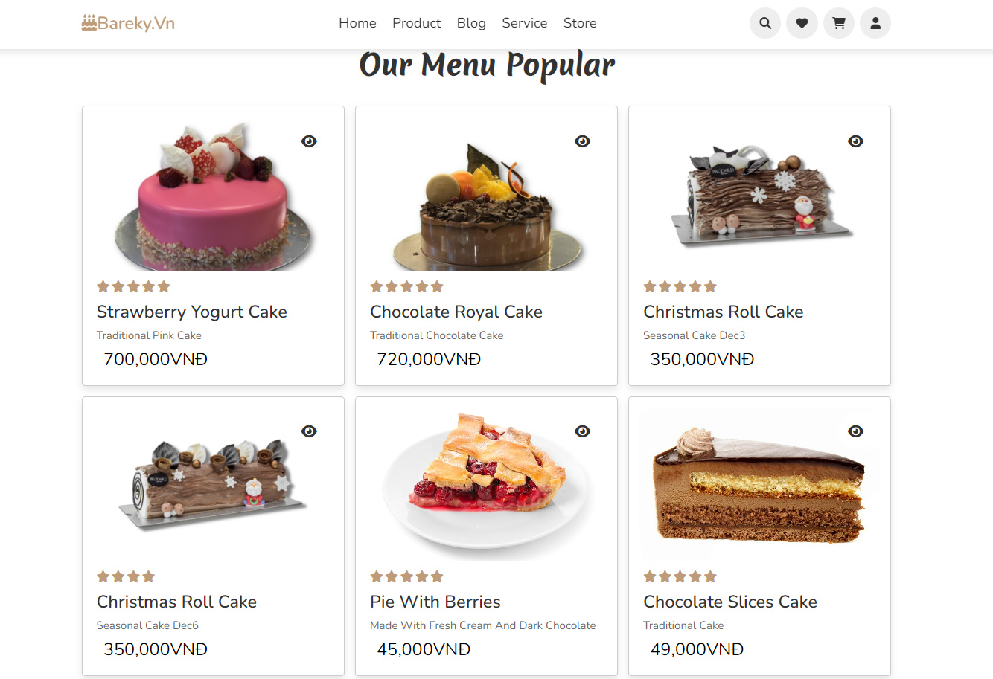

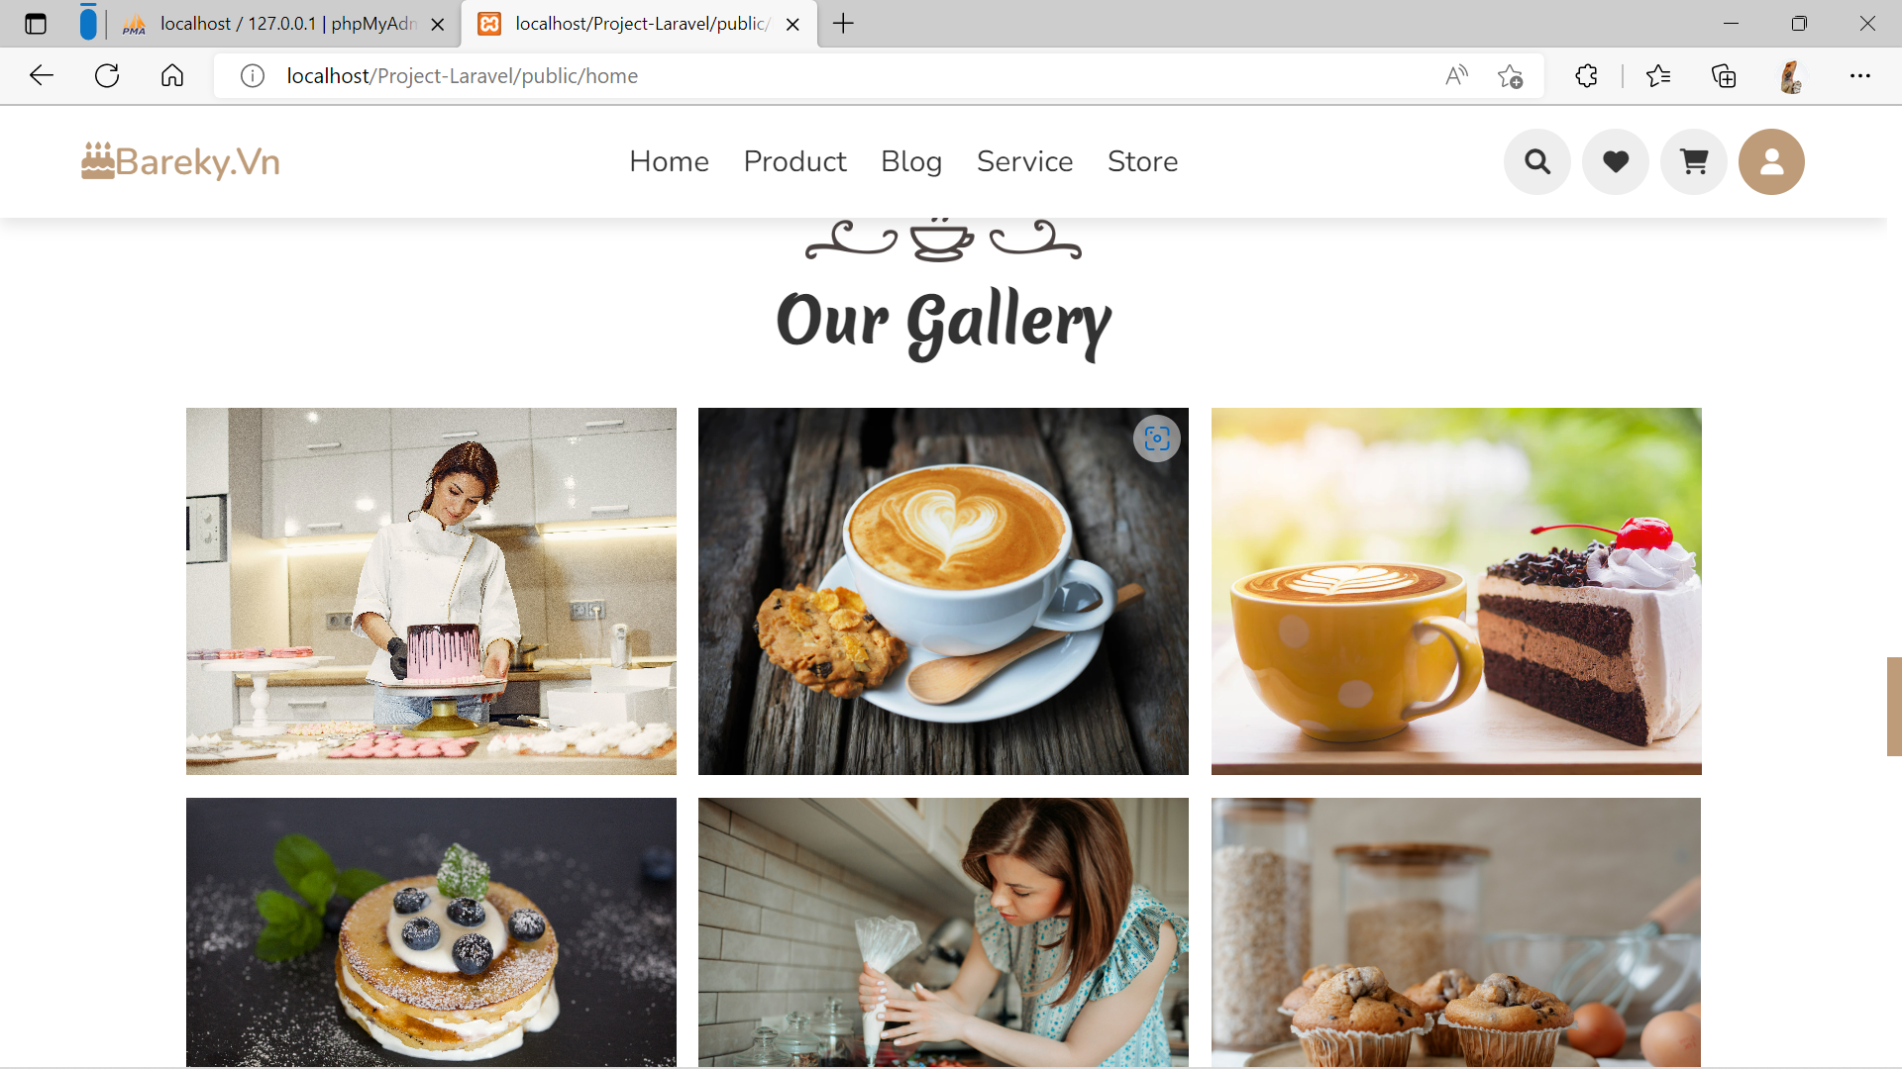

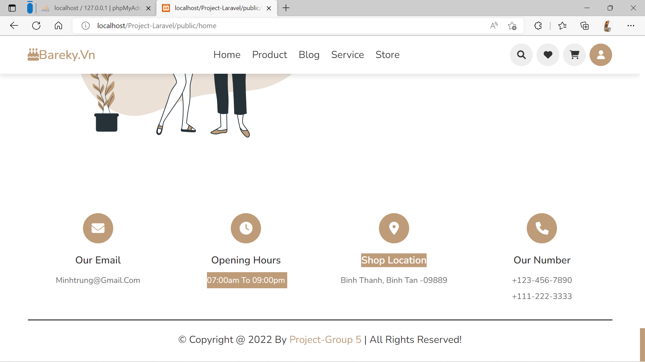

LOGIN

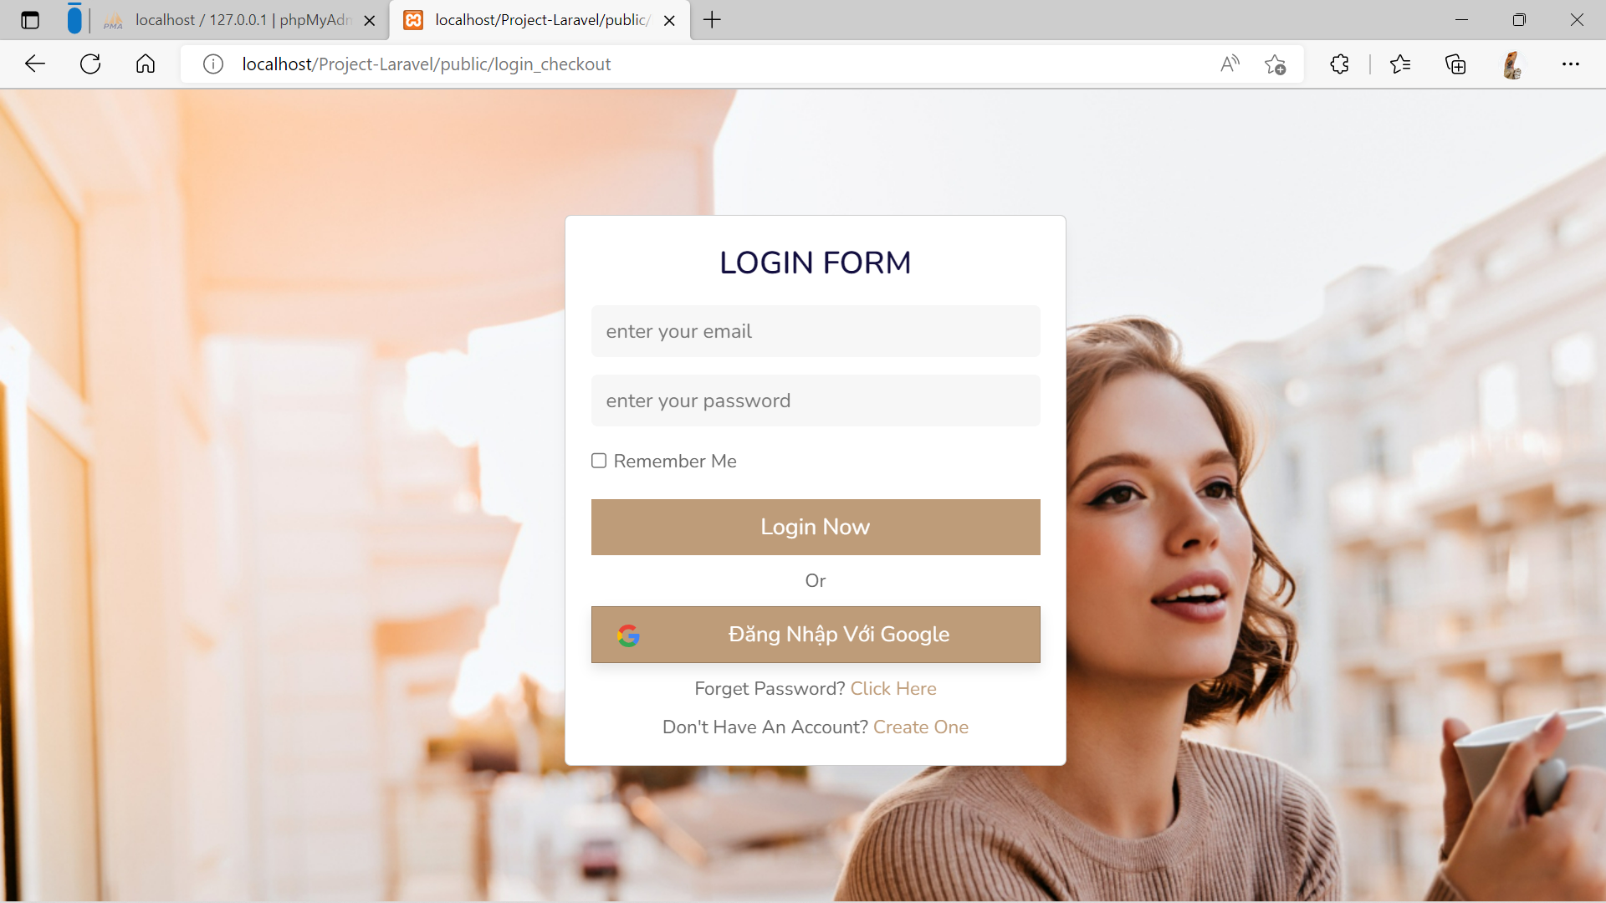

**REGISTER PAGE**

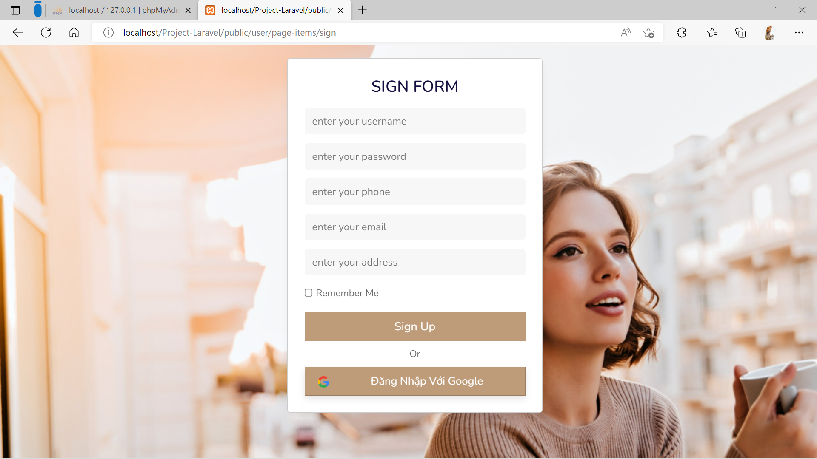

**Product**

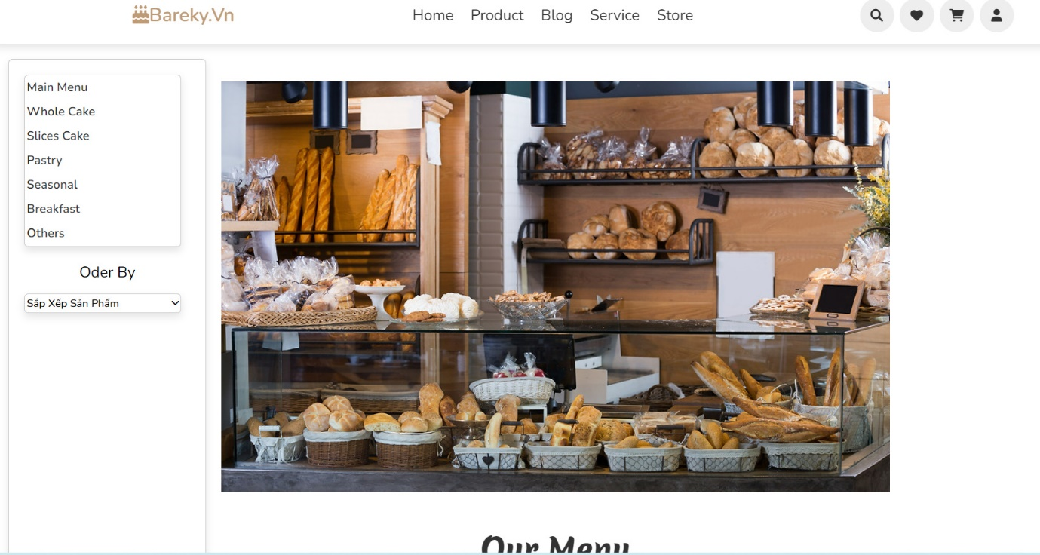

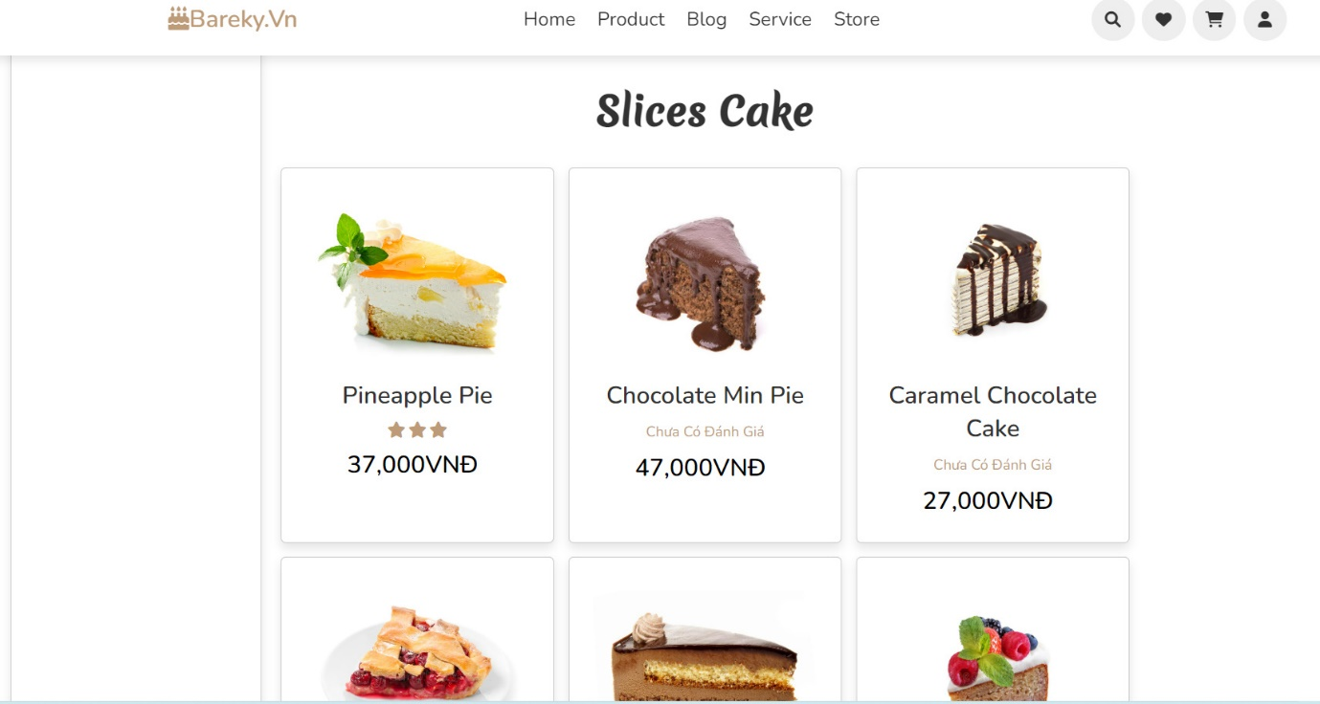

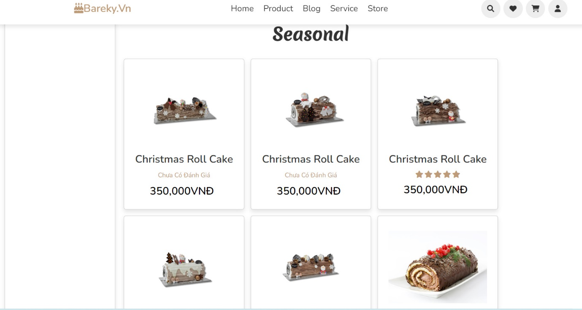

**ProductDetails**

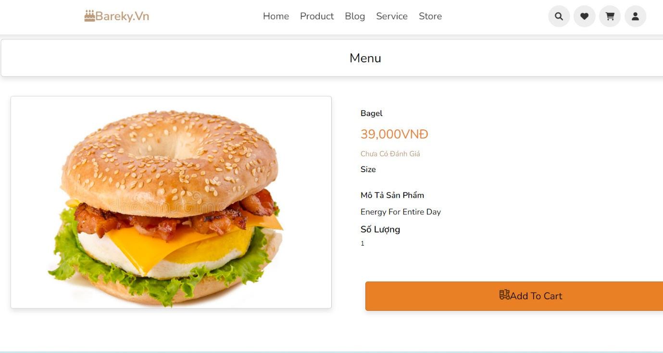

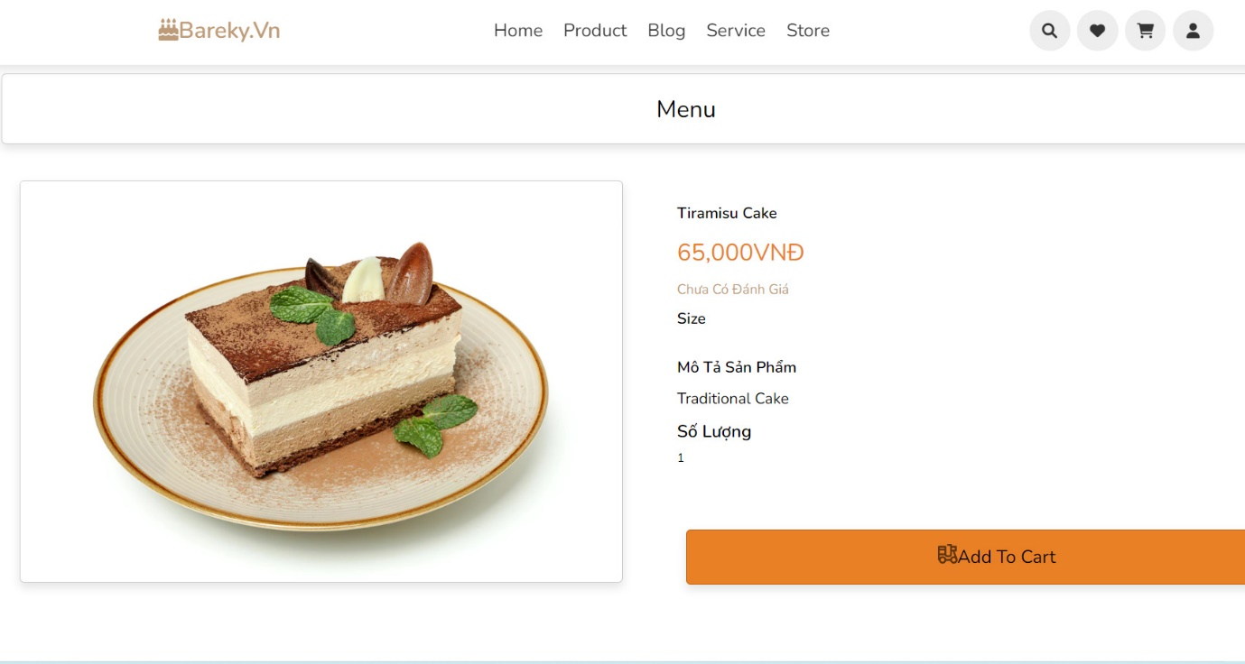

**Store**

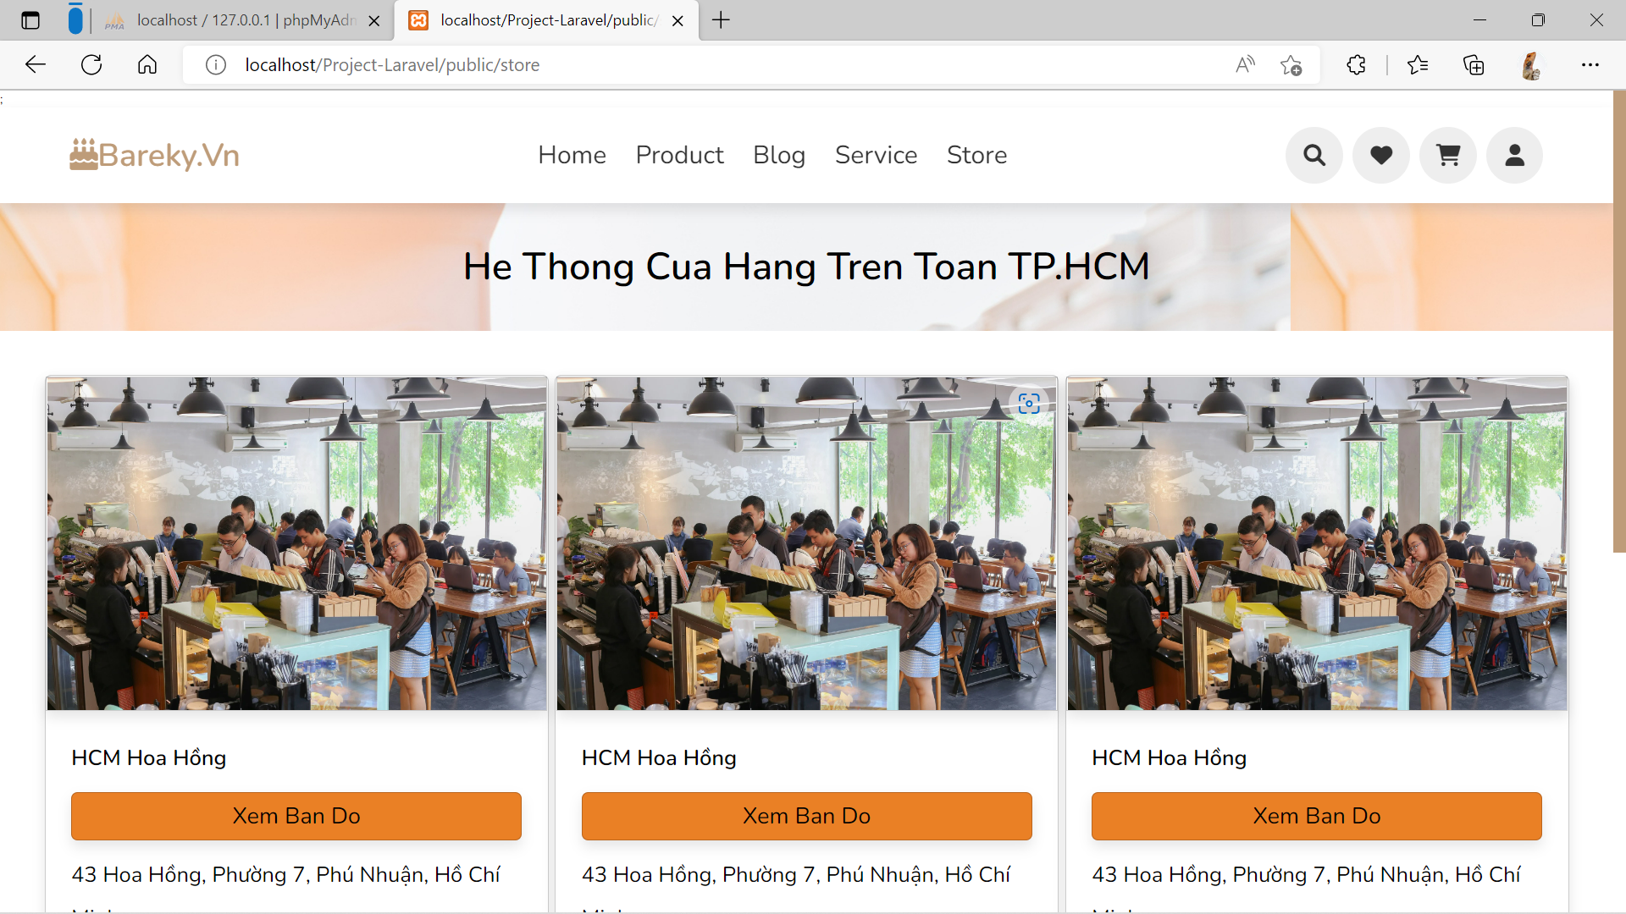

**Service**

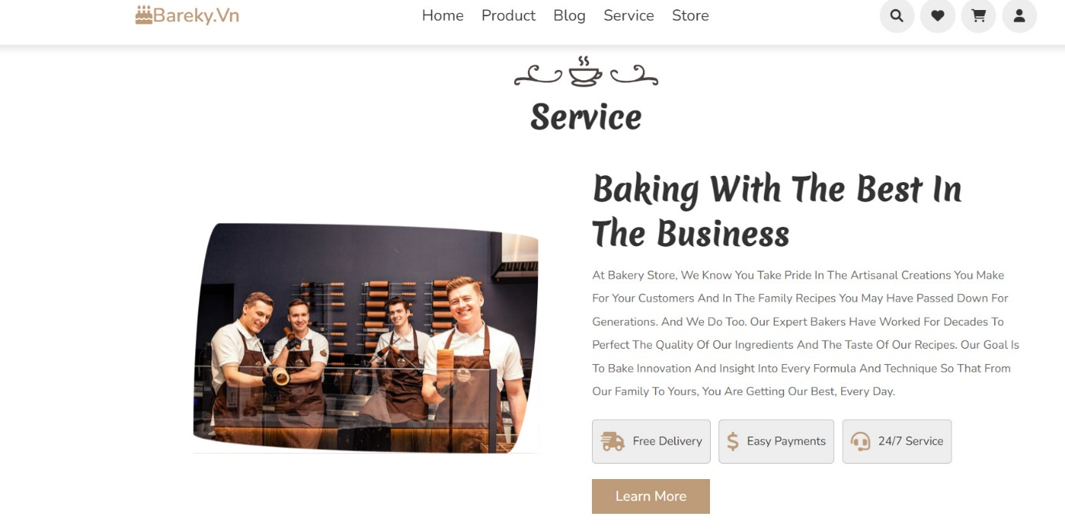

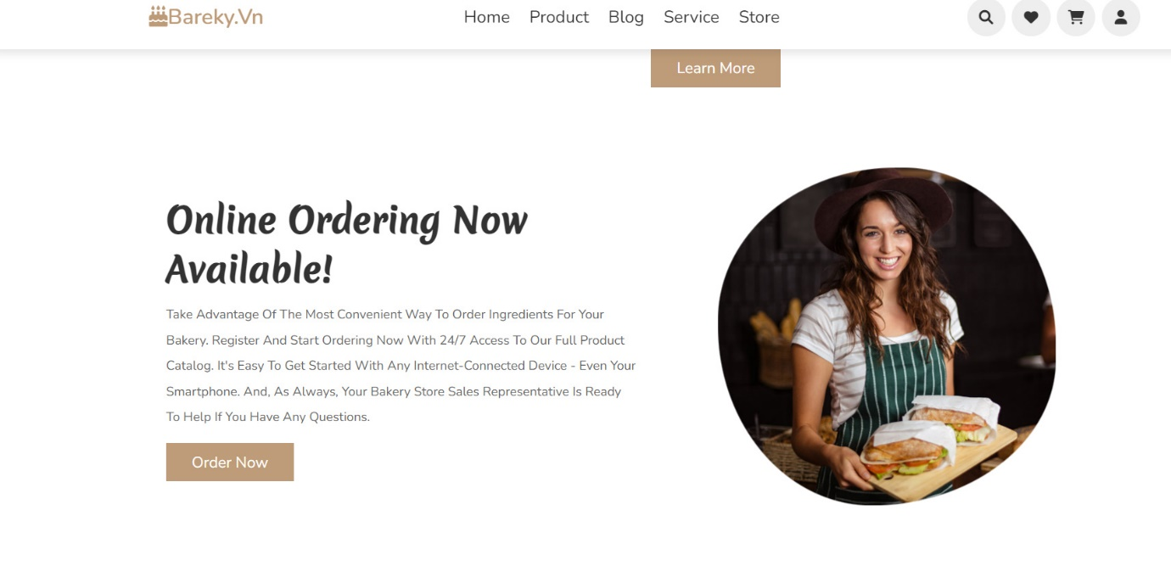

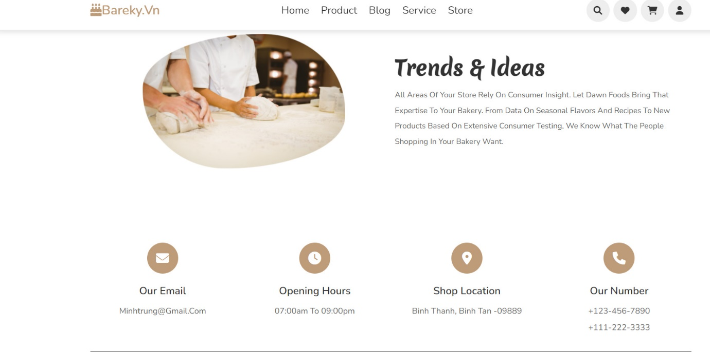

**Blog**

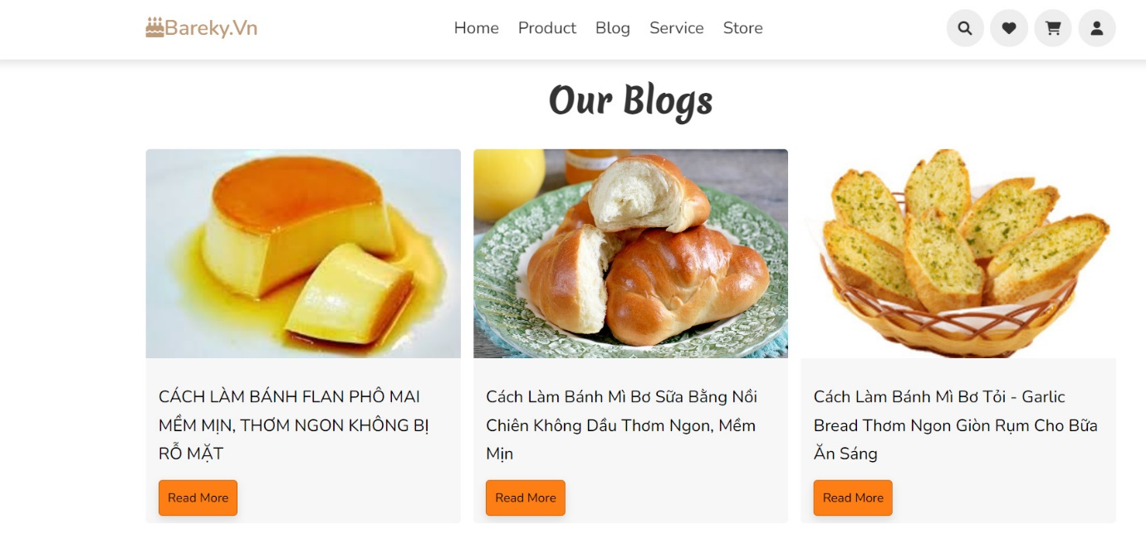

**Blog-Details**

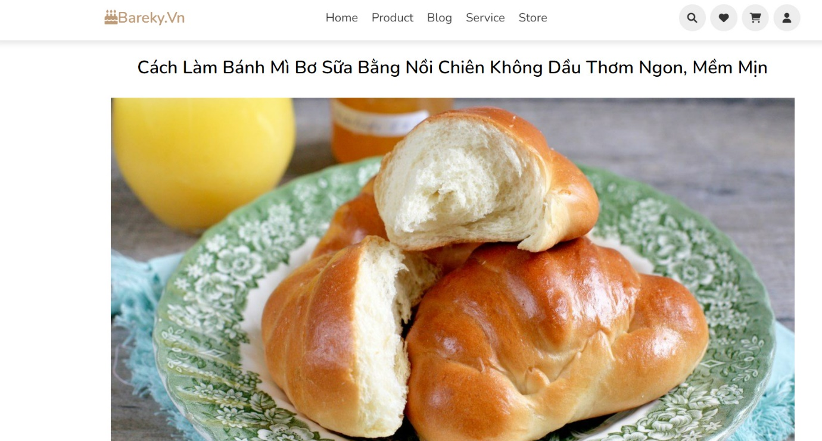

**CHECK-OUT PAGE**

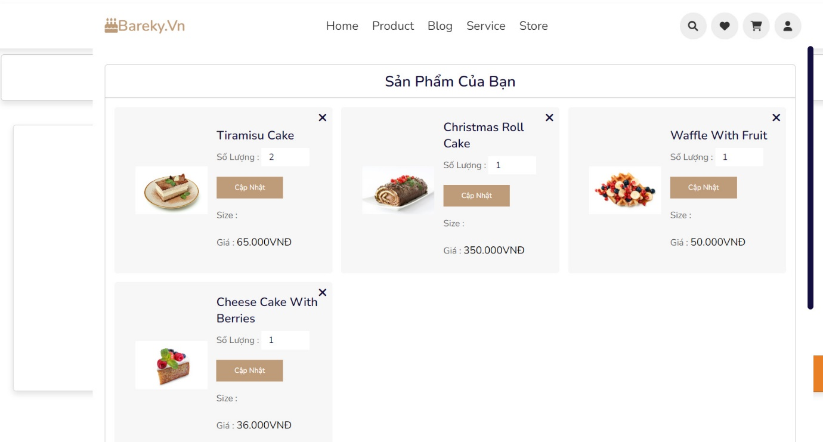

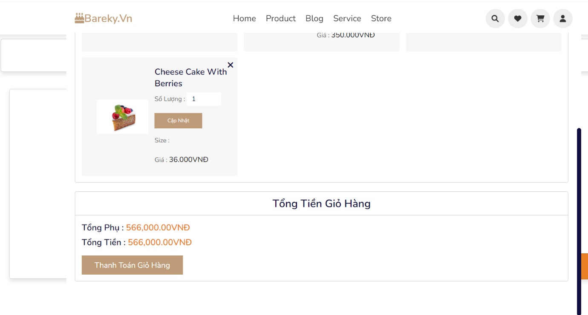

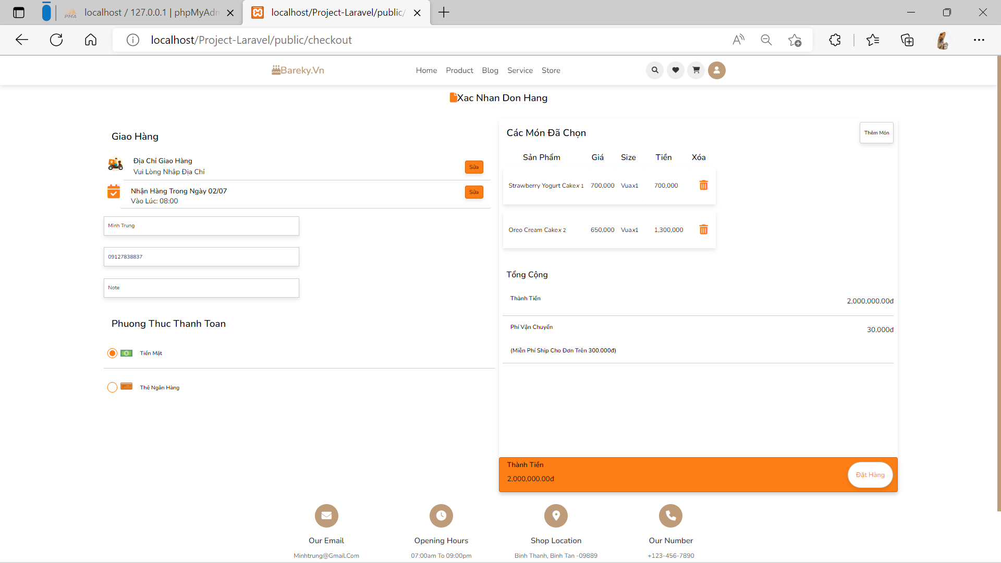

ADMIN PAGE

Order

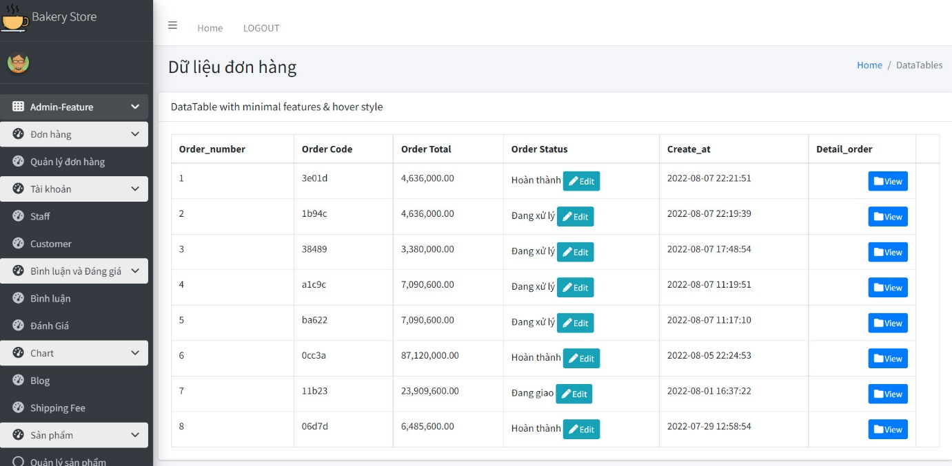

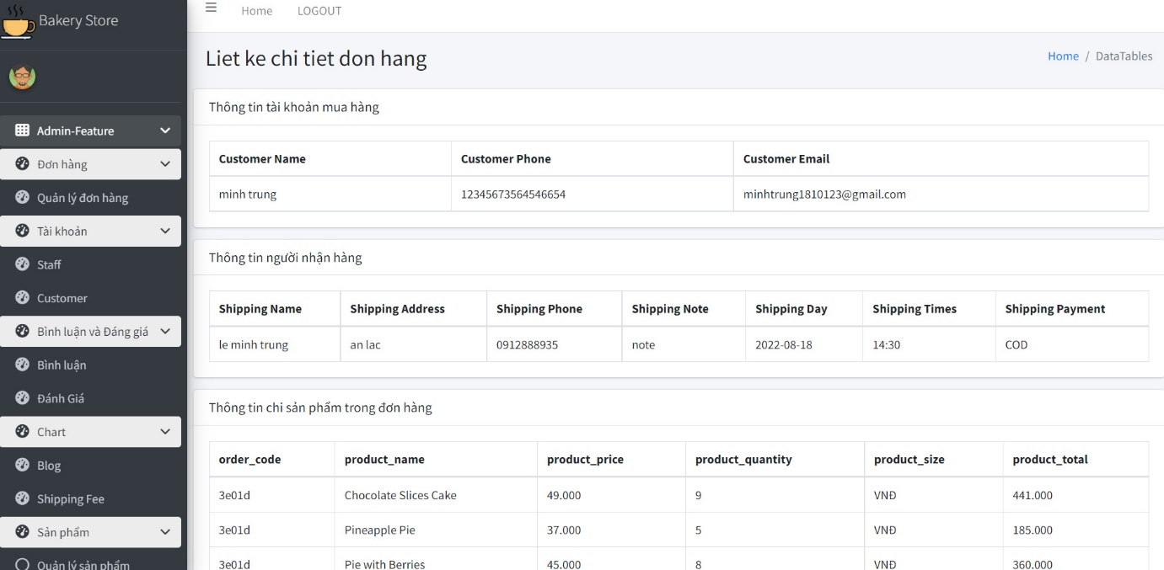

Comment

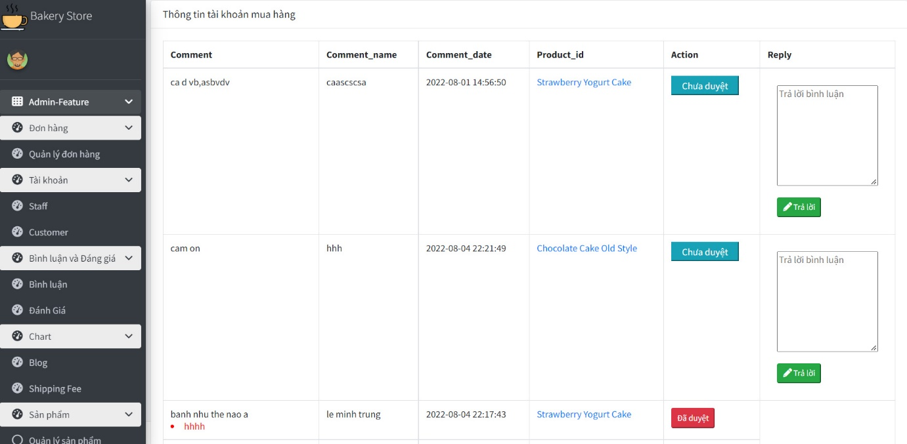

Leave star

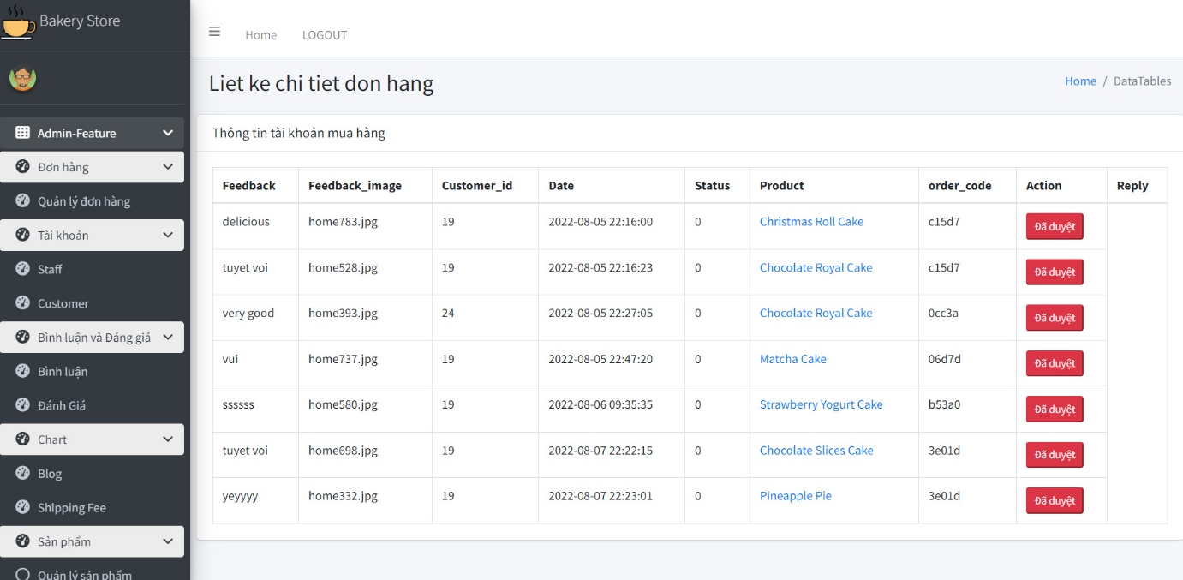

Product Manage

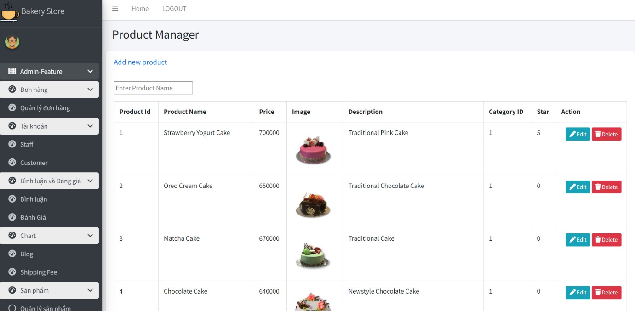

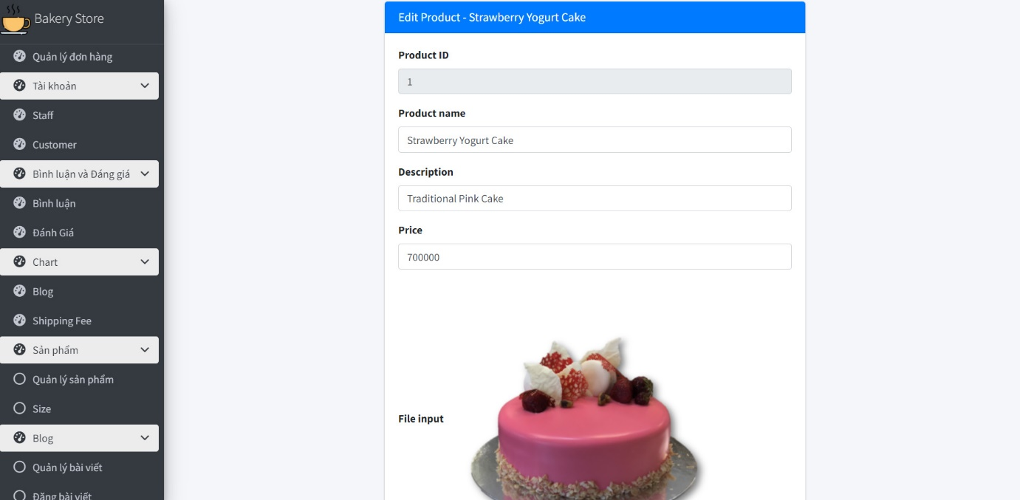

Size

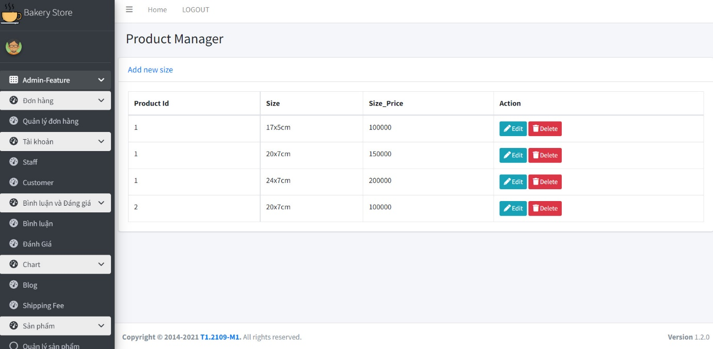

Blog

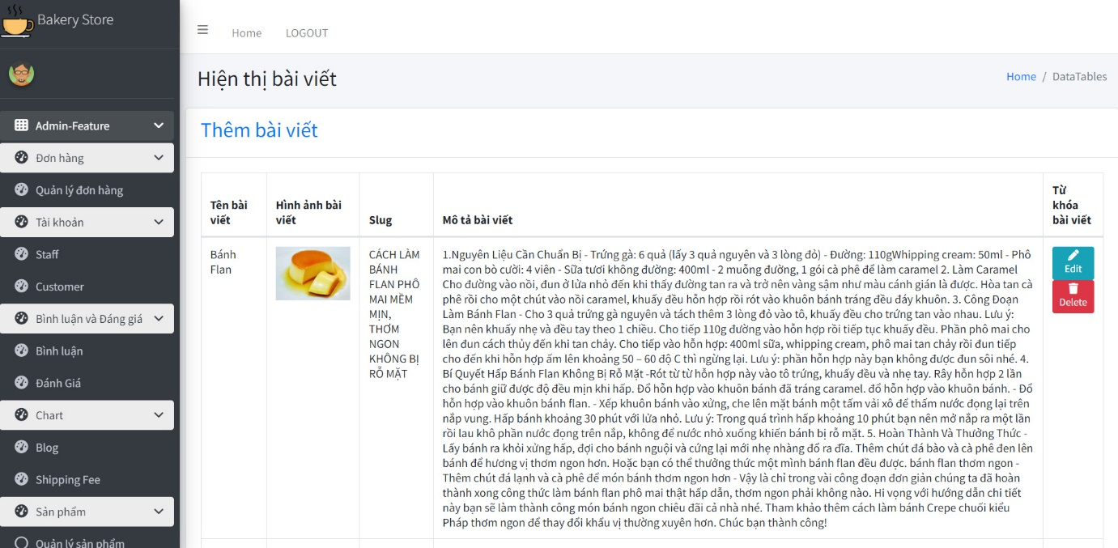

**Review 3 - Task Sheet**

|  |  |  |  |  |  |  |
| --- | --- | --- | --- | --- | --- | --- |
| **Project Ref. No.: Project title: Decos Store** | | **Activity Plan Prepared by: Thuy** | | **Date of Preparation of Activity Plan** | | |
| **Sr.No.** | **Task** | **Start Date** | **End Date** | **Actual day** | **Member’s Name** | **status** |
| 1 | All Customer Page | 11 July 2022 | 16 July 2022 | 3 | Trung | Complete |
| 2 | All Admin Page |

### Group Leader Faculty

Lê Minh Trung Ms. Le Mong Thuy